**AWS CLOUD COMPUTING**

**Practical no.1**

**AIM:** *Demonstrate creation Of Windows EC2 Instance.*

## **Step 1. Select a region**

One of the most important steps is to select the desired AWS region. This can be done from the top navigation bar of the AWS Console.

## **Step 2. Navigate to the EC2 Console**

Once you select the desired AWS region, go to the EC2 Console. From the same landing page, search for EC2. Your landing page in the management interface will likely display EC2 among the most commonly used services in the account.

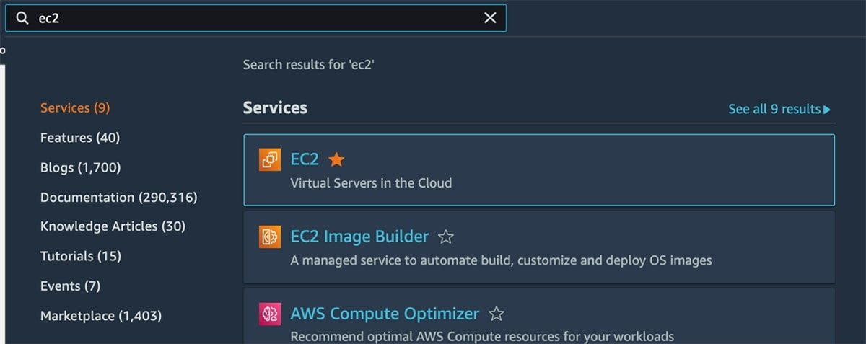

Once you arrive at the EC2 Console, from the left navigation menu, choose the Instances option.

**Step 3. Create the EC2 instance**

An EC2 instance is a virtual server deployed in the AWS cloud. The first server-specific configuration to choose is the [Amazon Machine Image](https://www.techtarget.com/searchaws/definition/Amazon-Machine-Image-AMI) (AMI). An AMI is a base server image stored in the cloud. It contains the OS, preinstalled software as well as data included in the EC2 instance when it launche and click launch instances.

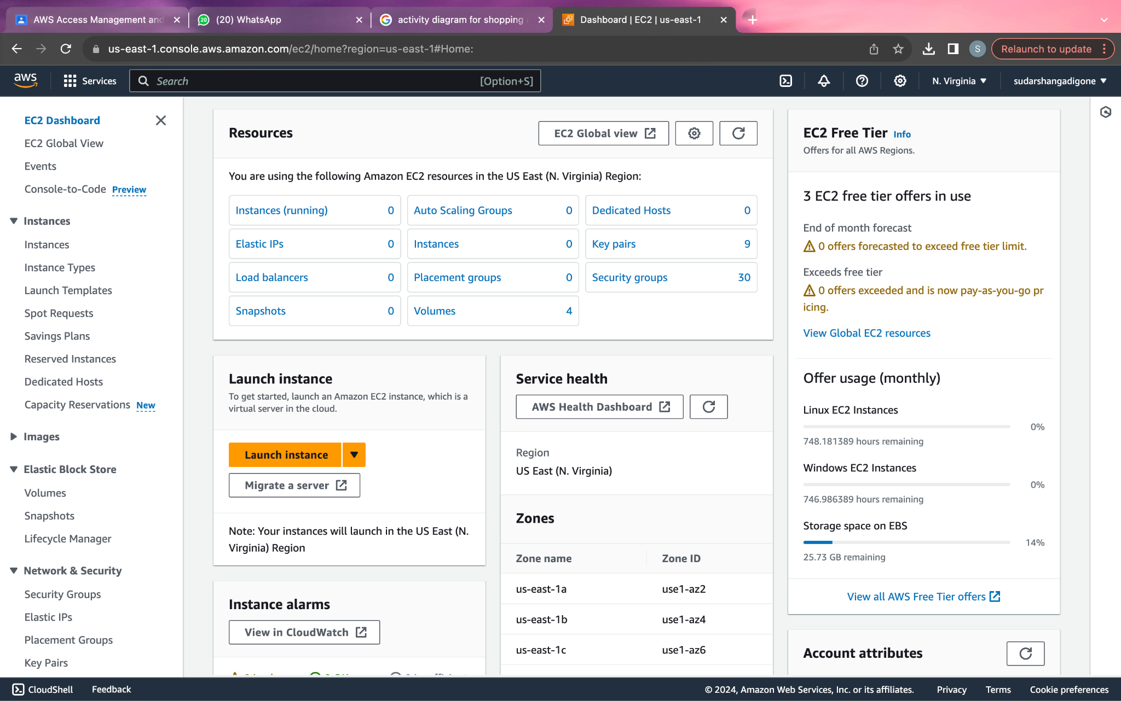

After clicking launch instances select the microsoft windows option to create an EC2 instance for windows.

## 

## 

## 

## 

## 

## **Step 4. Choose an instance type**

After selecting the AMI, the next step is to choose an instance type . There are [close to 500 types](https://aws.amazon.com/ec2/instance-types/) of EC2 instances in instance families. They are grouped by characteristics in terms of compute, memory, storage and networking resources. Most instances are billed by the minute. Pricing is proportional to the resources allocated to it, such as memory, vCPUs, Elastic Block Store (EBS)/SSD storage and the network's data throughput rate.To select an EC2 instance, you must understand the application infrastructure requirements and the right EC2 instance type to meet them. Under-provisioned EC2 instances encounter performance problems, while over-provisioned instances result in an unnecessarily high bill.

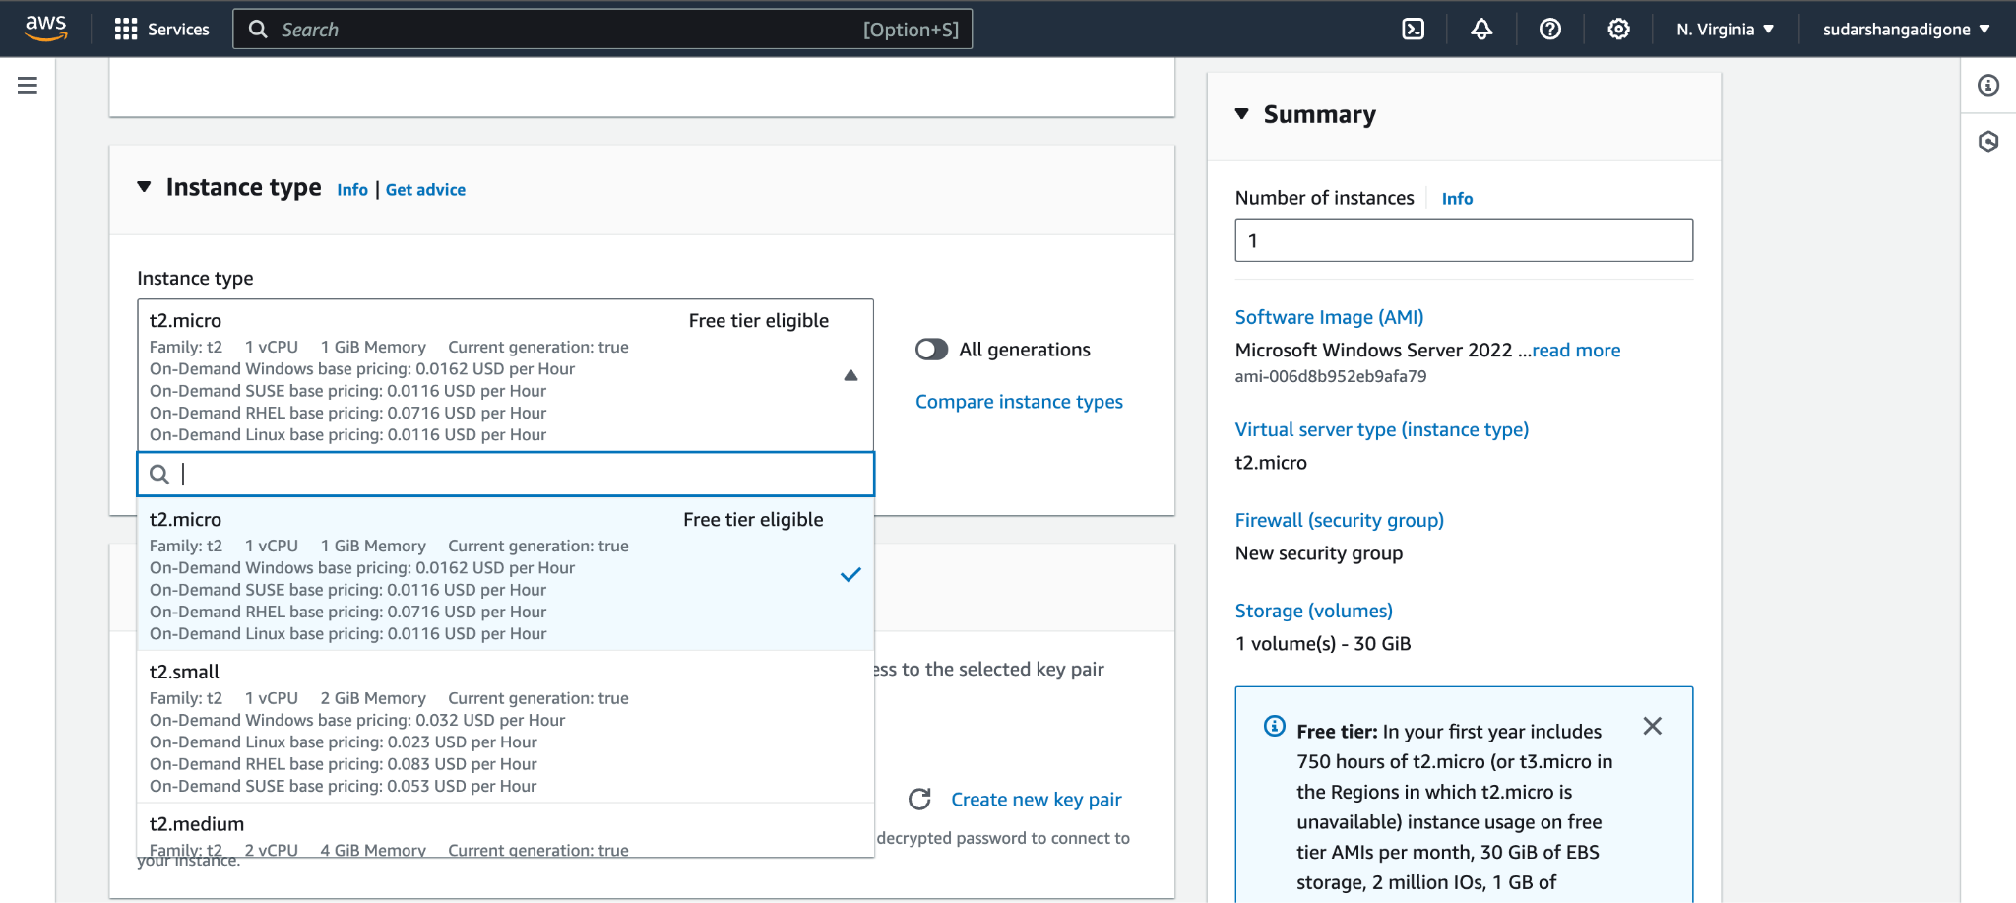

**Step 5.** Create a key pair for WINDOWS EC2 instance and then launch instance.

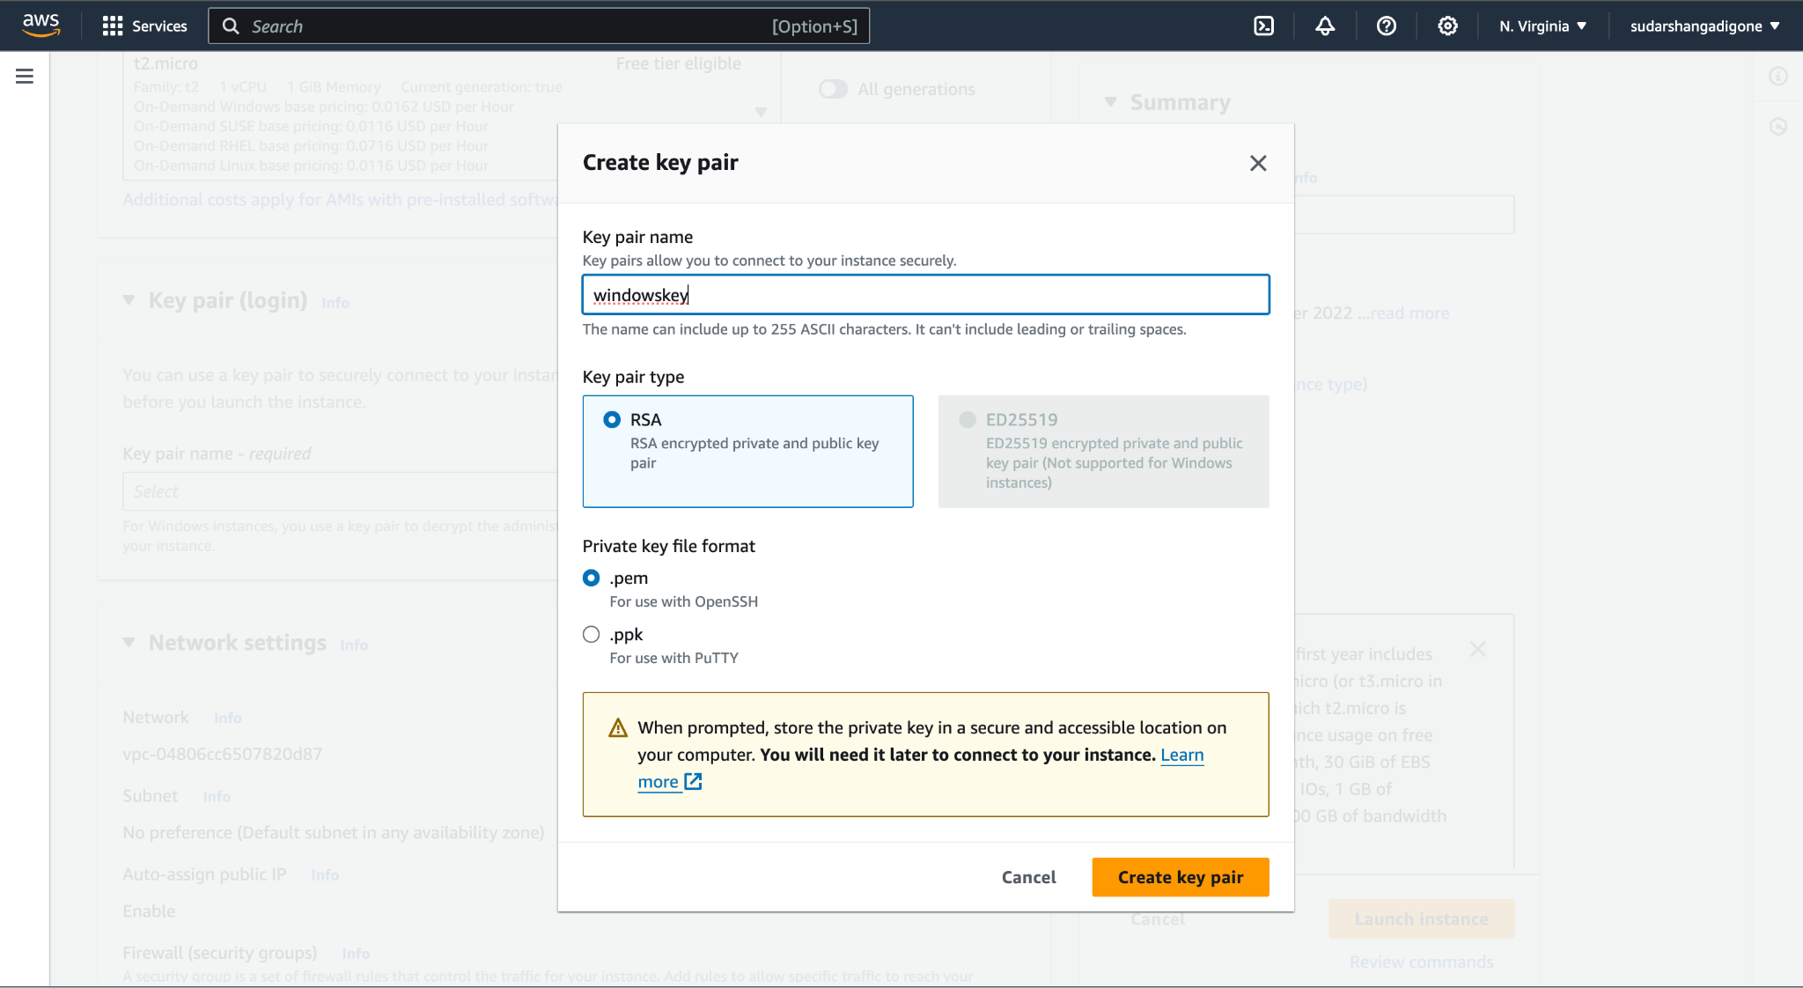

The last step is to create an EC2 key or select an existing one. The key is used to enable Secure Shell (SSH) access into the EC2 instance. With Windows instances, the private EC2 key helps generate an admin password to access the instance. AWS stores a copy of the public key inside the EC2 instance. Users keep the private key.It's the developer's responsibility to [store the generated key file in a secure location](https://www.techtarget.com/searchsecurity/answer/SSH-security-risks-Assessment-and-remediation-planning), given that this file enables someone to access the EC2 instance and run commands in it.Once this step is completed, the EC2 instance goes into a pending state, which typically lasts less than one minute. The instance then transitions into a running state, and it's ready to be used.

**Step 6. Configure Storage**

Most EC2 instances attach to an EBS volume, which is configured in this section. Specify the storage size in gigabytes and the storage type options. Options include various generations of general-purpose SSD or provisioned IOPS as well as older-generation magnetic volumes (not recommended). Storage-optimized instance types, such as EC2 C5d, come with built-in SSD storage. Users can also choose a shared file system powered by the EFS service.

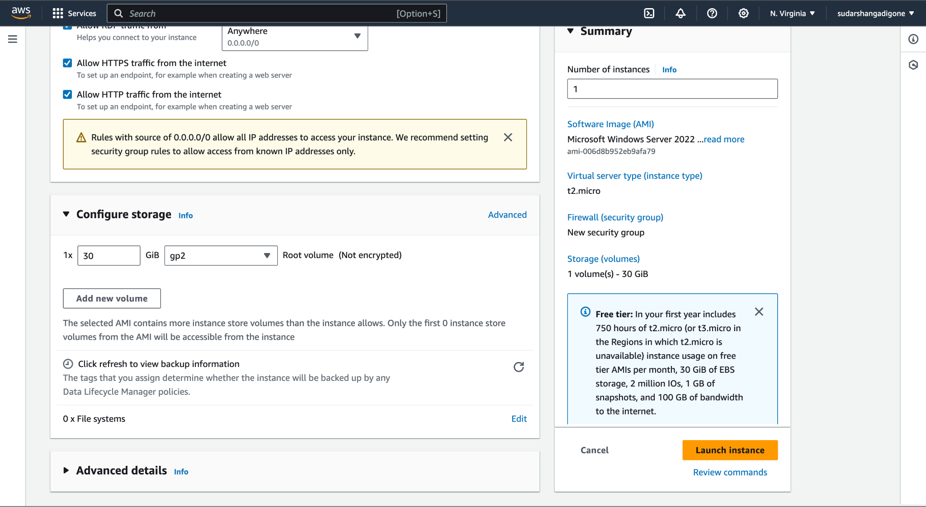

**Step 7. Launch the instance by clicking on launch instances on the bottom right of the screen.**

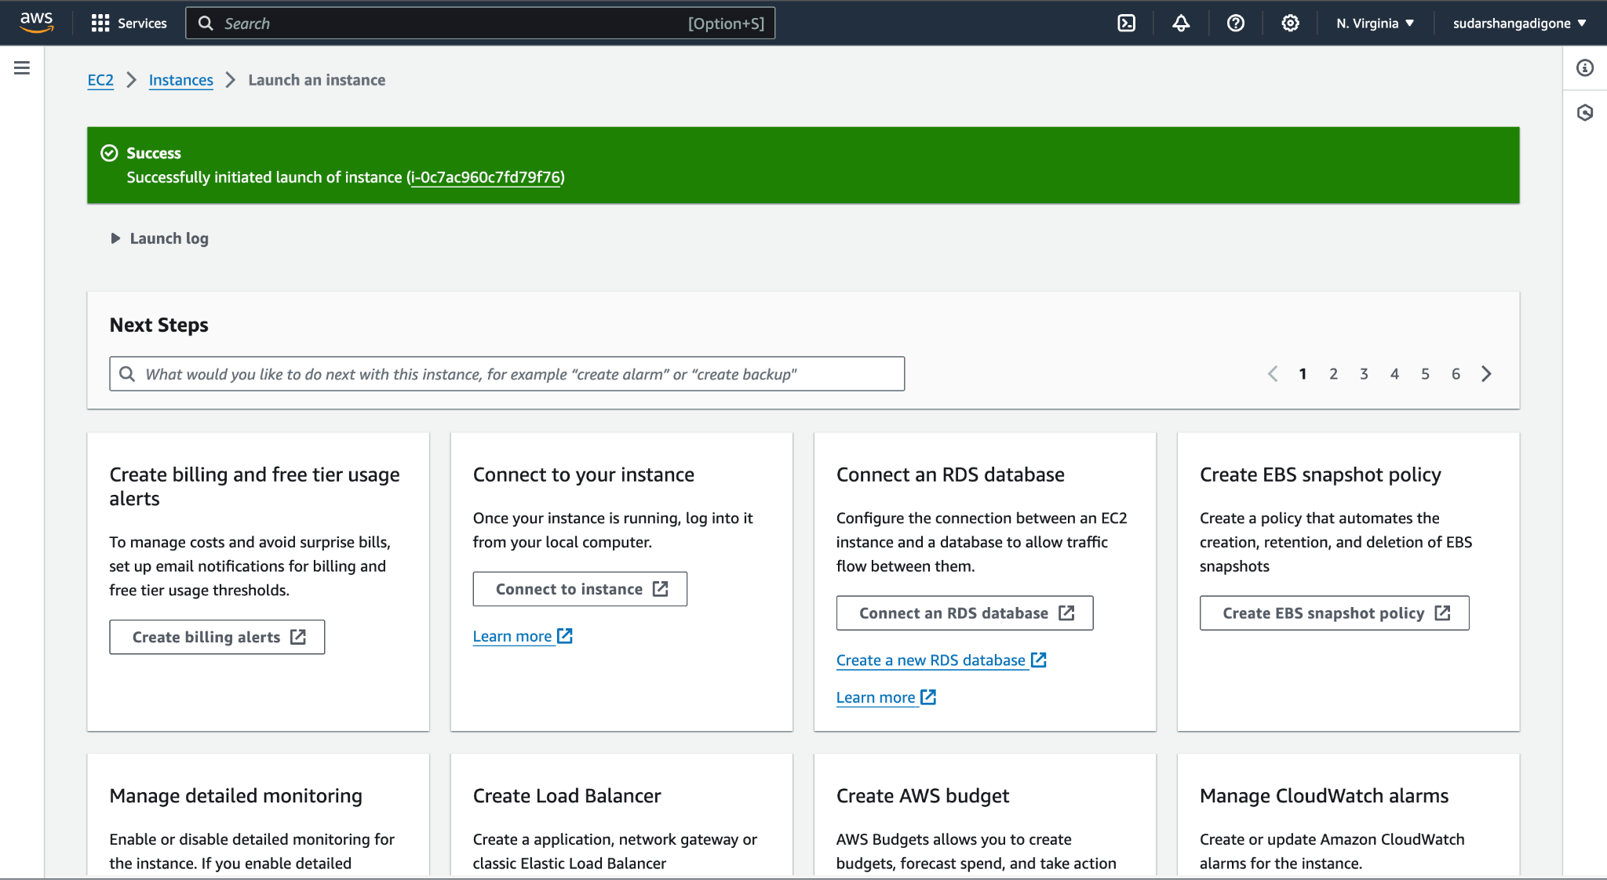

This type of dialogue box will appear showing that the instance has been created successfully.

Then click on the instance.

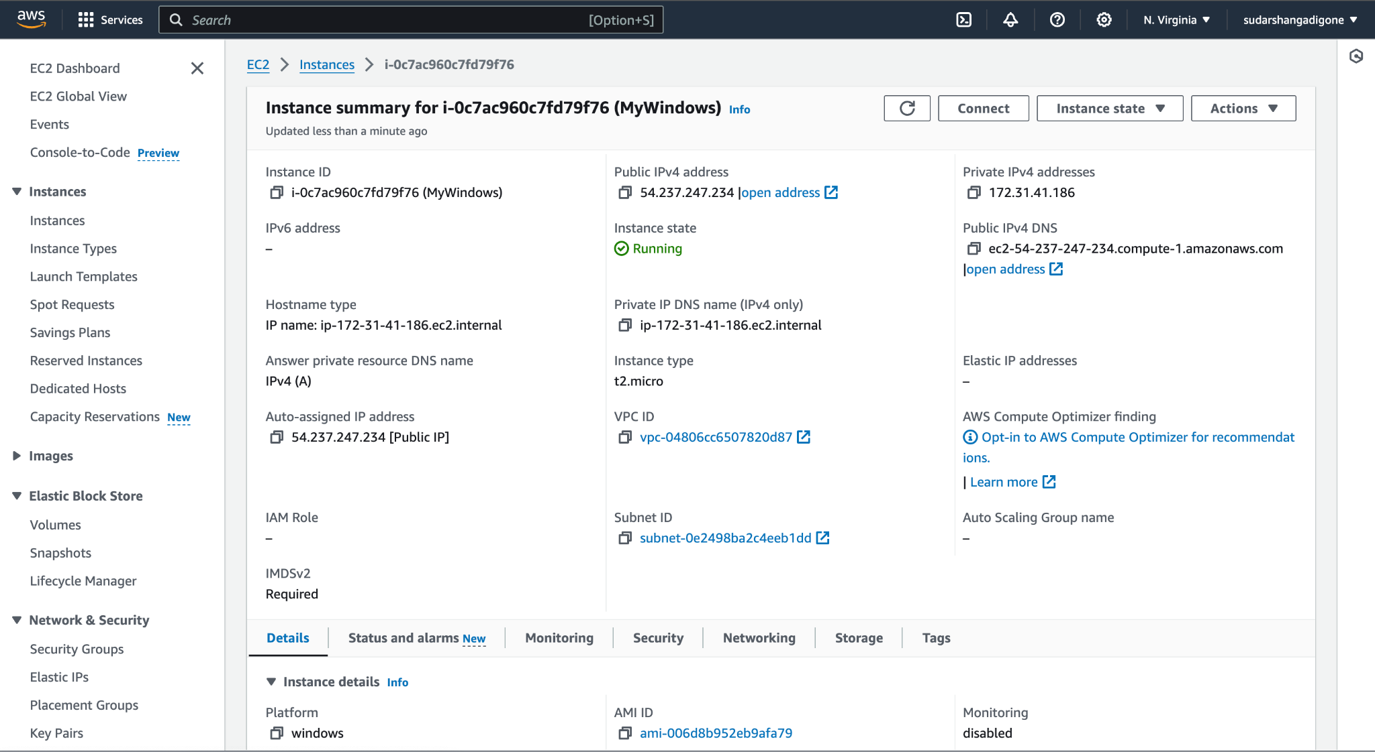

This screen will appear showing the instance state and other configurations.

Hence, we have successfully created an instance.

**CONCLUSION**:

Thus we have successfully created Windows EC2 Instance.